**Faculty of Engineering, University of Jaffna**

**Department of Computer Engineering**

**EC2010: Computer Programming**

**Lab Assignment**

**1 Hour and 30 Minutes**

**There are two tasks. Implement all and you will be graded in Lab.**

Learn:

1. **You are given a sample program linear search**

#include<iostream>  
using namespace std;  
  
void LinearSearch(int arr[], int len, int item){  
  
 for(int i=0;i<len;i++){  
 if(arr[i] == item){  
 cout << item << " Found at index : " << i;  
 return;  
 }  
 }  
 cout << "Not found";  
   
}  
  
int main() {  
 int arr[] = {10, 5, 15, 21, -3, 7};  
   
 // calculating length of array  
 int len = sizeof(arr)/sizeof(arr[0]);  
   
 // item to be searched  
 int item = 21;  
 LinearSearch(arr, len, item);  
  
 return 0;  
}

Output: 21 Found at index : 3

**Program 02: Swapping**

#include <iostream>  
using namespace std;  
  
int main()  
{  
 int a = 5, b = 10, temp;  
  
 cout << "Before swapping." << endl;  
 cout << "a = " << a << ", b = " << b << endl;  
  
 temp = a;  
 a = b;  
 b = temp;  
  
 cout << "\nAfter swapping." << endl;  
 cout << "a = " << a << ", b = " << b << endl;  
  
 return 0;  
}

Output

Before swapping.  
a = 5, b = 10  
  
After swapping.  
a = 10, b = 5

Task:

01. Implement a technique that searches a value (search key) in a sorted array by repeatedly dividing the search interval in half. It begins with an interval covering the whole array. If the value of the search key is less than the item in the middle of the interval, narrow the interval to the lower half. Otherwise narrow it to the upper half. It will repeatedly check until the value is found or the interval is empty.

Eg: Search for 9 in a sorted array with size of 10

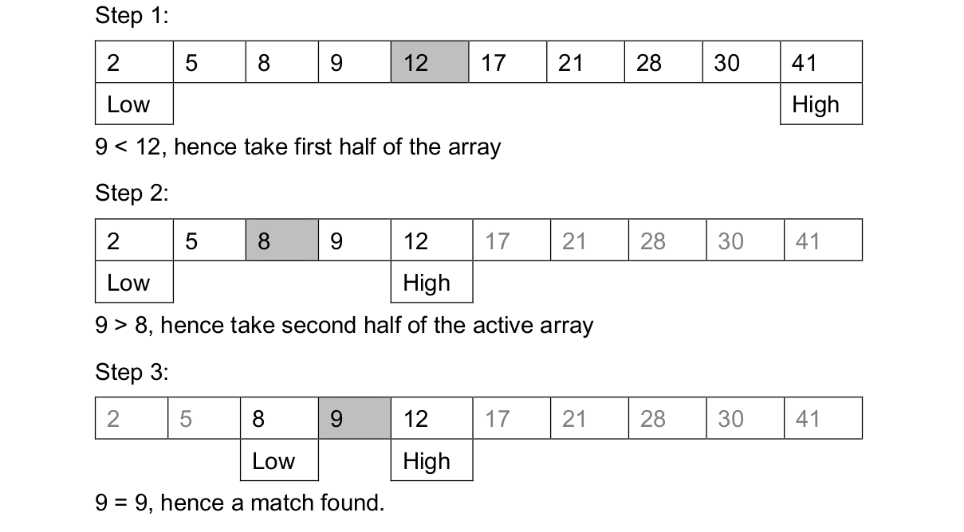

Task: Write a C++ program for the explained search on a given sorted array with known size of n.

The program should have a function with the definition ***int search(int array[], int key, int low, int high)***. This function repeatedly searches for the key as shown in the figure. Each time, key is compared with the middle element. If the search key not found and less than the middle element, compare with middle element of the elements on its left side, otherwise compare with middle element of the elements on its right side.

In the main function, for a given sorted array, if the element searched is found print “Element Found in index i”, if not, print “Element not found”. Here “i” is the index of the element searched and found.

02: Write a C++ program for the following patters

